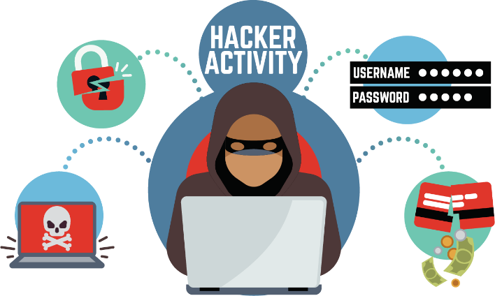

WIRE FRAUD ADVISORY

Criminals are targeting social media and email to steal information. This is particularly common in real estate transactions because sensitive data, including social security numbers, bank account numbers, and wire instructions are often sent by electronic means. We do not want you to be the next victim of wire fraud. Money wired to a fraudulent account is stolen money that typically cannot be recovered. Additionally, there is generally no insurance for this loss. You may never get the money back.

**PROTECT YOURSELF**

**VERIFY AND NOTIFY**

**ONLINE RESOURCES:**

There are many online sources that can provide useful information regarding similar topics including, but not limited to, the following sites:

The Federal Bureau of Investigation @ [www.fbi.gov/scams-and-safety](http://www.fbi.gov/scams-and-safety) The Internet Crime Complaint Center @ [www.ic3.gov](http://www.ic3.gov/)

On Guard Online @ [www.onguardonline.gov](http://www.onguardonline.gov/)

Consumer Financial Protection Bureau (CFPB) @ [www.consumerfinance.gov/](http://www.consumerfinance.gov/about-us/blog/mortgage-closing-scams-how-protect-yourself-and-your-closing-funds/)

[about-us/blog/mortgage-closing-scams-how-protect-yourself-and-your-closing-funds/](http://www.consumerfinance.gov/about-us/blog/mortgage-closing-scams-how-protect-yourself-and-your-closing-funds/)

# DO NOT TRUST ANY EMAIL(S) CONTAINING WIRE INSTRUCTIONS

* If you receive an email containing wire transfer instructions, immediately call your escrow officer to ensure the validity of the instructions.

# DO NOT TRUST EMAILS SEEKING PERSONAL/FINANCIAL INFORMATION

* If you receive an email requesting personal/financial information or asking you to download, click on a link, send, and/or do anything that may seem unusual to you, call your escrow officer immediately prior to acting on the suspicious email to verify the validity of the email.

# TRUST YOUR SOURCE OF INFORMATION

* Never direct, accept or allow anyone in the transaction to consent to receiving transfer instructions without a direct personal telephone call to the individual allegedly providing the instructions.
* It is imperative that this call be made to a number obtained in person from the individual or through other reliable means, not from a number provided in the email or the wiring instructions.

**Before you wire funds to any party (including your lawyer, title agent, mortgage broker, or real estate agent) personally meet them or call a verified telephone number (not the telephone number in the email) to confirm before you act!**

**Immediately notify your banking institution and Settlement/Title Company if you are a victim of wire fraud.**

**The undersigned acknowledges receipt of this Wire Fraud Advisory.**

|  |  |  |  |  |
| --- | --- | --- | --- | --- |
| Name |  |  | Name |  |
| Signature | Date |  | Signature | Date |