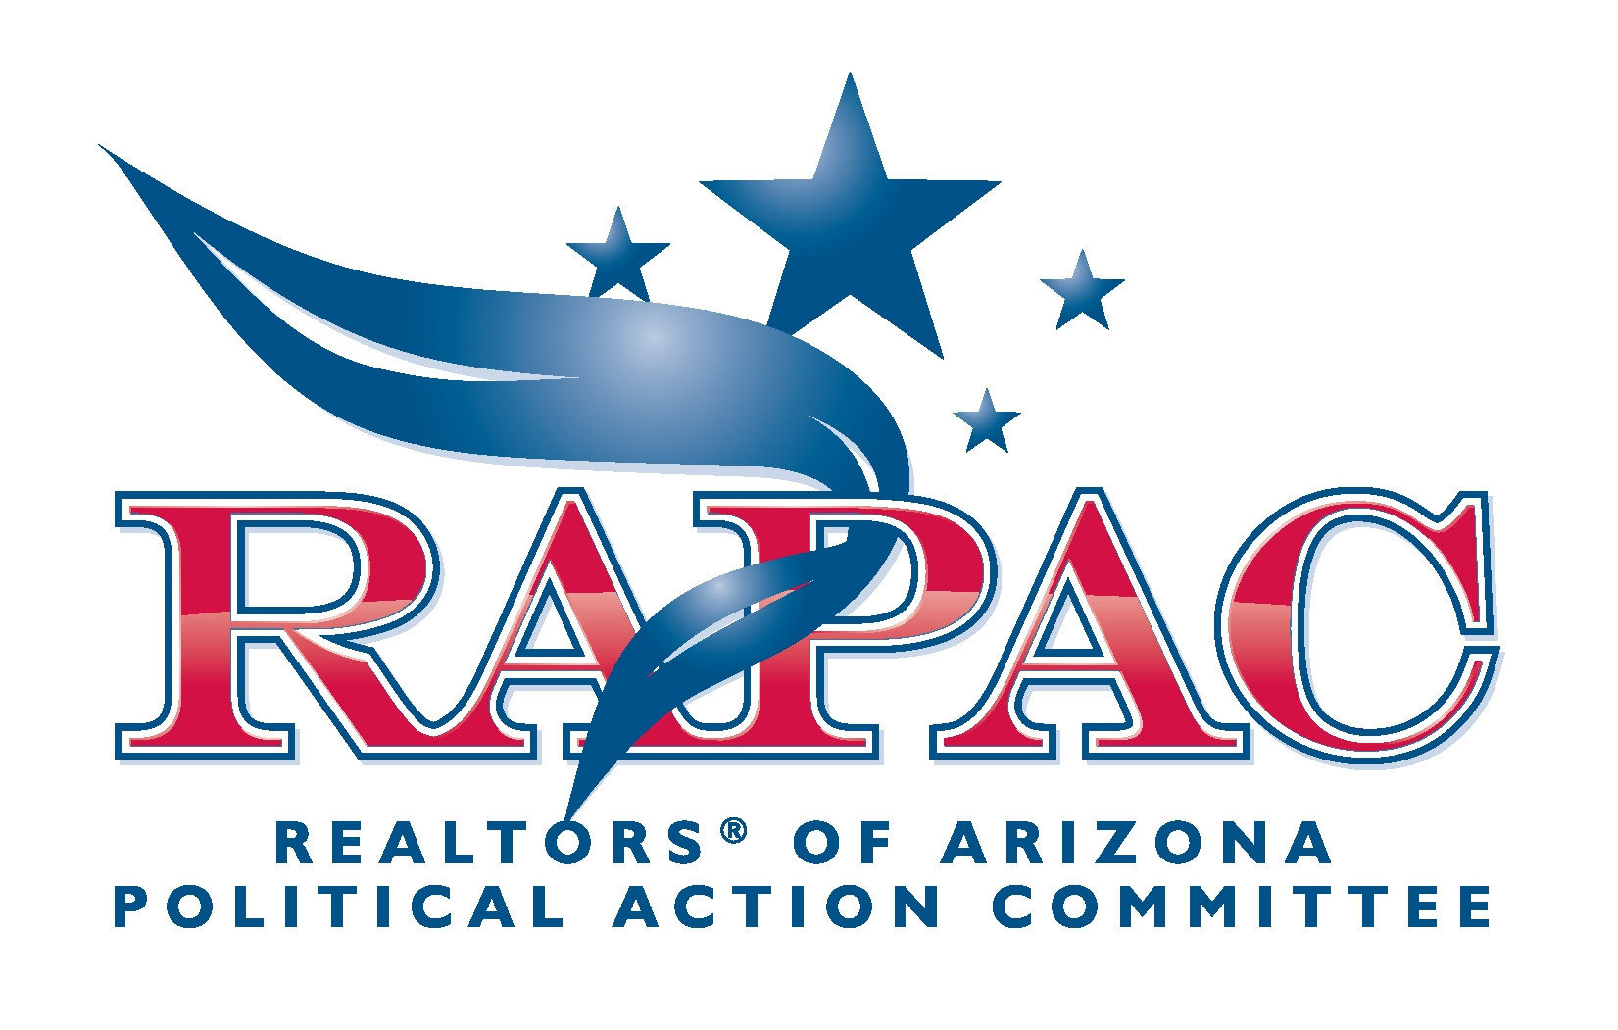

Puts Money in Your Pocket ...
and Keeps the Government Out of It!

RAPAC saves you more than your FAIR SHARE contribution!

WHAT A DIFFERENCE RAPAC MAKES!

Supporting the election of U.S. Senators and Congressmen who stand for free enterprise, private property rights, keeping government limited, providing for our common defense and promoting principles of a sound economy.
Supporting state and local legislative candidates who pledge to improve the “business climate” in Arizona for REALTORS® and others.
Preventing numerous “regulations” from being promulgated that would have been costly and would have added legal risks to doing business.

