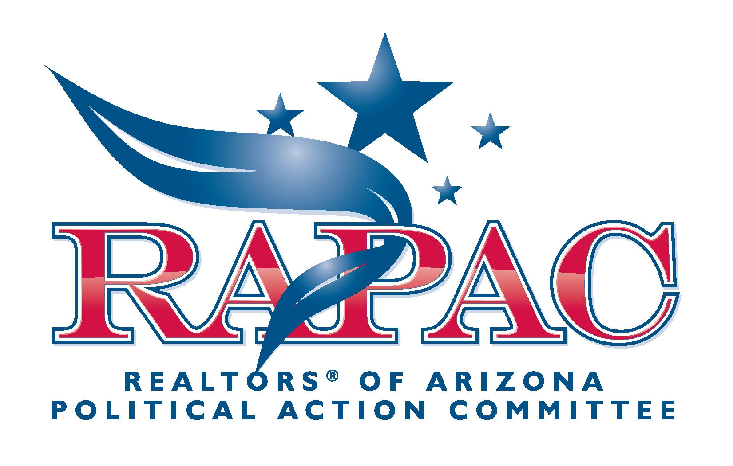

JOIN US!
Help RAPAC Change the Face of Arizona Politics!

We can change public policy by electing more pro-real estate candidates to the Arizona Legislature.

By working together REALTORS® can make a difference in the political face of our state.

During the 2010 election cycle, RAPAC gave more than $100,000 to our supported candidates.

Since its inception, RAPAC has helped fund and elect a large number of candidates to public office. In addition to direct financial support of candidates, RAPAC also makes independent expenditures, funding proven campaign techniques such as media appearances, press releases, newspaper and magazine advertisements, direct mail, yard signs, television and radio commercials, bumper stickers, and billboards. Scores of pro-real estate candidates across Arizona have received direct and indirect support through RAPAC.

As we head into another important election cycle, RAPAC welcomes and encourages your support. Your contributions are essential to execution of our missions.

REALTORS® OF ARIZONA POLITICAL ACTION COMMITTEE

Building Political Clout...
One Dollar at a Time

Your voluntary contribution to the RAPAC fund goes directly to candidates who support AAR’s Legislative Priorities.

A minimum contribution of $30, added to the contributions of other AAR members, grows quickly and equates to real clout!

CONTRIBUTE TO RAPAC
JOIN US TODAY!

