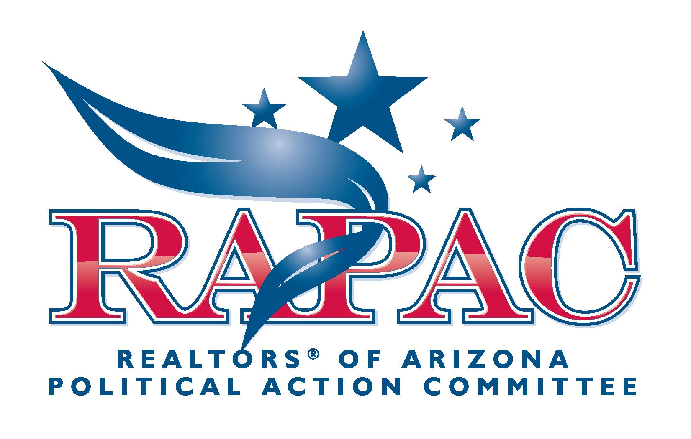

"Every man owes a part of his time and money to the business or industry in which he is engaged. No man has the moral right to withhold his support from an organization that is striving to improve conditions within his sphere."
-Theodore Roosevelt

The effectiveness of your Association's government affairs representation at the local, state and federal levels directly depends upon your support. Once a year, AAR members are asked to make a voluntary contribution to RAPAC to help AAR's lobbying efforts.

More than 15 percent of all proposed legislation introduced at the Capitol each year affects REALTORS®. That amounts to almost two hundred bills each year! Most of the bills introduced are designed to increase REALTOR® liability and reduce private property rights. Supporting your REALTOR® PAC is the only way to ensure your right to do business is protected.

RAPAC has a proven track record in candidate campaigns, but needs sufficient funds to protect your business interests in Arizona. In order to change the laws we must be proactive and support the best pro-business lawmakers.

The true cost for REALTORS® doing business in Arizona is $30-a minimal commitment for the entire year-that's only 57 cents a week!

It only takes two minutes to write a check or sign a credit card authorization for your contribution to REALTOR® political success. Call 602-248-7787 or toll free at 1-800-426-7274 (outside of Phoenix) for details.

