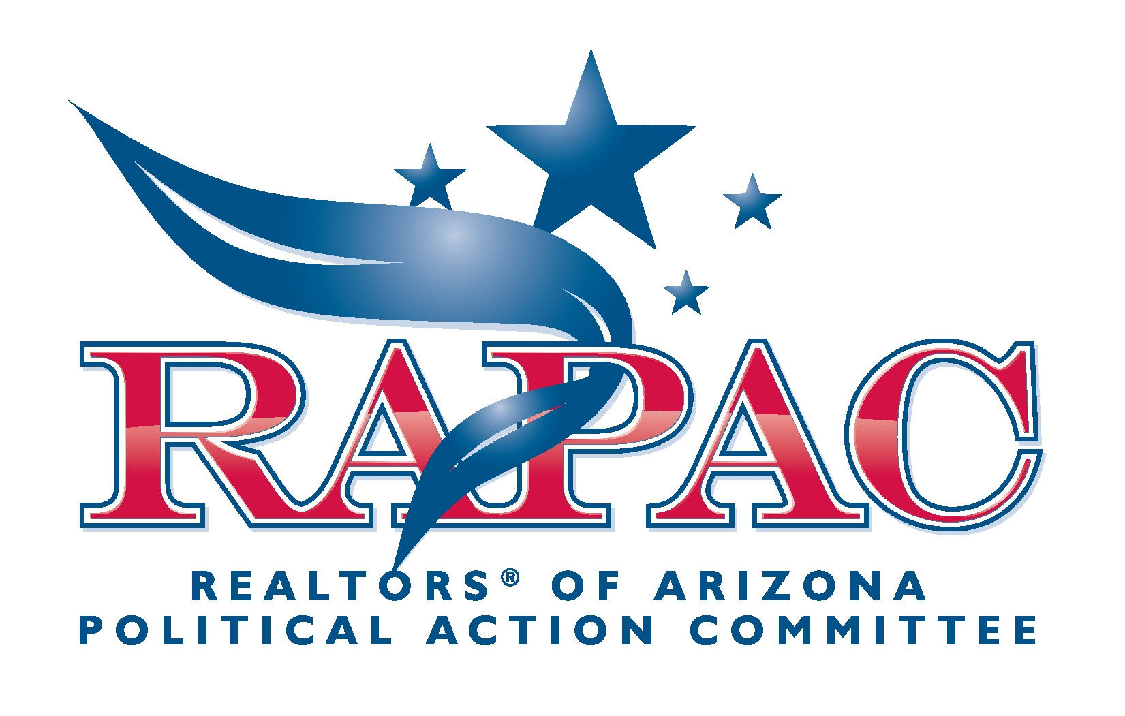

The Makings of a Successful RAPAC Campaign

We all know how hard it is to ask people for money, even when it is for a worthy cause. We don’t want to impose on people and we don’t want to appear to be begging for handouts. We also may feel that talking about money and how much someone can afford to contribute as crass or inappropriate. Nothing could be farther from the truth! Fundraising for RAPAC is not about asking for a handout--it’s about giving your members the opportunity to contribute to the continued success of their livelihood!

Keep that all-important concept in mind when planning your next RAPAC fundraiser as your campaign should center around it.

Do you remember the old adage “What you conceive and believe, you will achieve”? Well, it holds true for RAPAC campaigns as well. There are five basic traits that are essential to conducting a successful fundraiser.

- Believe in Your Cause
If you truly believe in your cause you will have no problem convincing others to do so as well. The best sales people in any industry are those who have “bought into” their own product. Nothing “sells” others on a concept more than a dedicated believer. If you truly believe in the tremendous benefits of RAPAC and support it, others will follow your lead.

- Take Pride in Your Cause
An energetic and enthusiastic person will generate more contributions in both dollar amount and sheer numbers that someone who feels awkward and comfortable asking for money.

- Don’t Focus on Money—Focus on the Opportunity To Invest in Our Industry
You are not asking for a handout, you are giving your member the opportunity to take a pro-active role in investing in their livelihood.

- Educate Your Members on RAPAC
Acquaint your members with RAPAC—how it is run, what the goals are, what the accomplishments have been over the years and what its direction is for the future. We want RAPAC to become the largest and most influential PAC in Arizona representing the interests of all residential and commercial real estate agents as well as private property owners’ rights.

- Stress the Remarkable Wins that RAPAC Already has Achieved
REALTORS® and the real estate industry have achieved many legislative victories because of membership’s RAPAC support.

