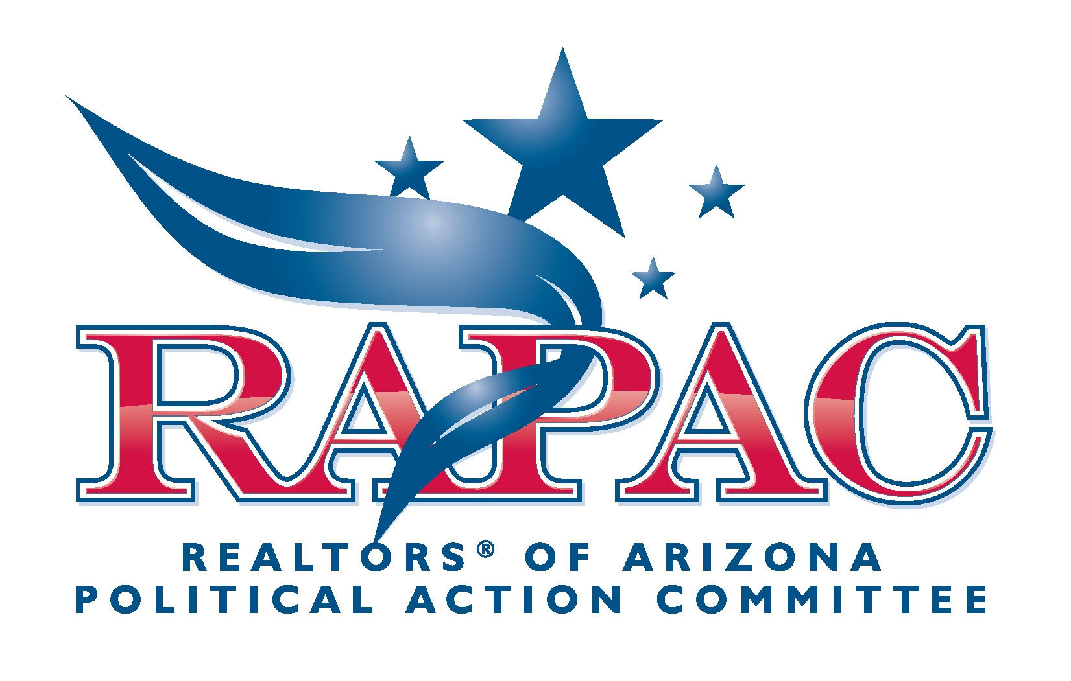

About the REALTORS® of Arizona Political Action Committee (RAPAC)

The REALTORS® of Arizona Political Action Committee (RAPAC) is a membership-sponsored effort organized to financially support candidates running for state and local office whose position on real estate regulation and a free-market business environment most closely represent the initiatives of AAR. RAPAC contributes to and channels resources into the races that will have the most impact on the real estate industry. The PAC is a voluntary, non-profit political action committee and operates independently of any political party.

RAPAC is a vital part of the Arizona Association of REALTORS®’ Government Affairs program – a program that includes professional lobbying, legislative analysis, grassroots contacts, and long-term political relationships. RAPAC strives to educate legislators about our industry and guarantees that no decision is made that will affect our industry, good or bad, until our voice is heard.

